Attachment H – Sampling Toolkit

H.ii: Ice Machines Sample Collection Procedure

Sample Collection Procedures:

• Initial Screening Sample 1E
Fill a suitable container (250 mL or larger, wide-mouthed bottle or other container) provided by the laboratory at least three- quarters full of ice. Do not touch the ice with your hands. Use the non-metal scoop or disposable plastic gloves provided by the laboratory to place the ice in the container.

If the lead level in Sample 1E exceeds 15 µg/L (ppb), collect a follow-up sample to determine if the source of the lead is the plumbing or the ice machine itself.

• Follow-Up Sample 2E
Disconnect the ice machine from the plumbing and look for a screen at the inlet. Remove the screen. If debris is present, forward a sample of the debris to the laboratory for analysis and clean out the remaining debris. The laboratory will determine whether lead solder is present. Clean the screen routinely to avoid accumulations of debris.

Collect the sample from the disconnected plumbing as close to the ice machine as possible. Fill the sample container with 250 mL of water. If no outlet is available, contact the ice machine manufacturer for recommendations that will minimize disruption of existing plumbing. Adding outlets or valves could add new sources of lead to the plumbing, even if the new devices are lead-free and meet NSF Standard 61, section 8. If a sample outlet or valve is available, collect the sample immediately after opening the outlet or valve.
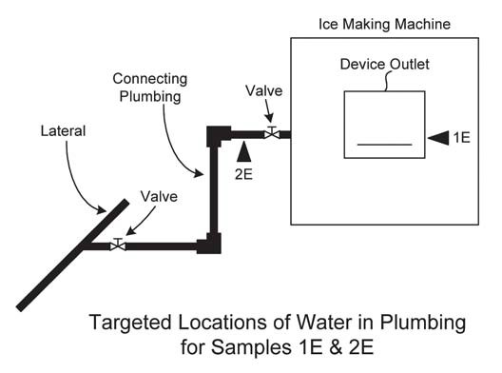

United States Environmental Protection Agency 3Ts for Reducing Lead in Drinking Water in Schools

